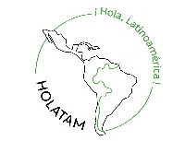
Please answer the following questions in detail outlining your skills and motivation to join our project.
We look forward to reading and getting to know you.

Name
Why would you like to participate in HOLATAM?

How would you describe yourself and how do you interact in a team?

Why are you interested in Latin Amercia?

What are your expectations towards the project?

What can you contribute to HOLATAM?

Which projects are you applying for? If you are interested in more than one, please list in order of preference.
- Choice Please choose
- Choice Please choose
- Choice Please choose

Max. one A4 page

